DIRECTIONS TO ADD MEDIA AND POST NEWS STORIES - By Scott Dickens
On www.ManchesterTwilightLeague.net (or .com)

- First… Log in on the main page with the login name and password I sent you.
  - 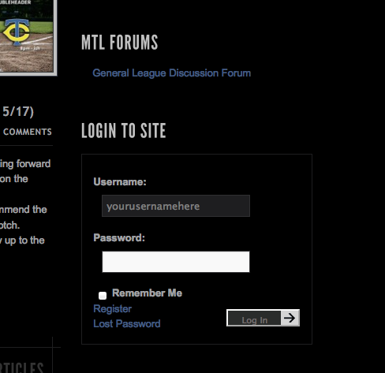

- This is the main layout of the Dashboard…where we manage all the content on the website…
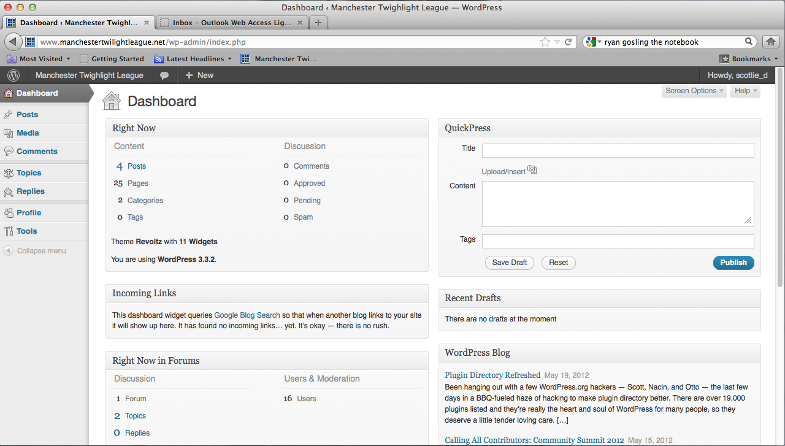

- To add a news story (a blog post)… click Posts on the left side, and then click Add Post
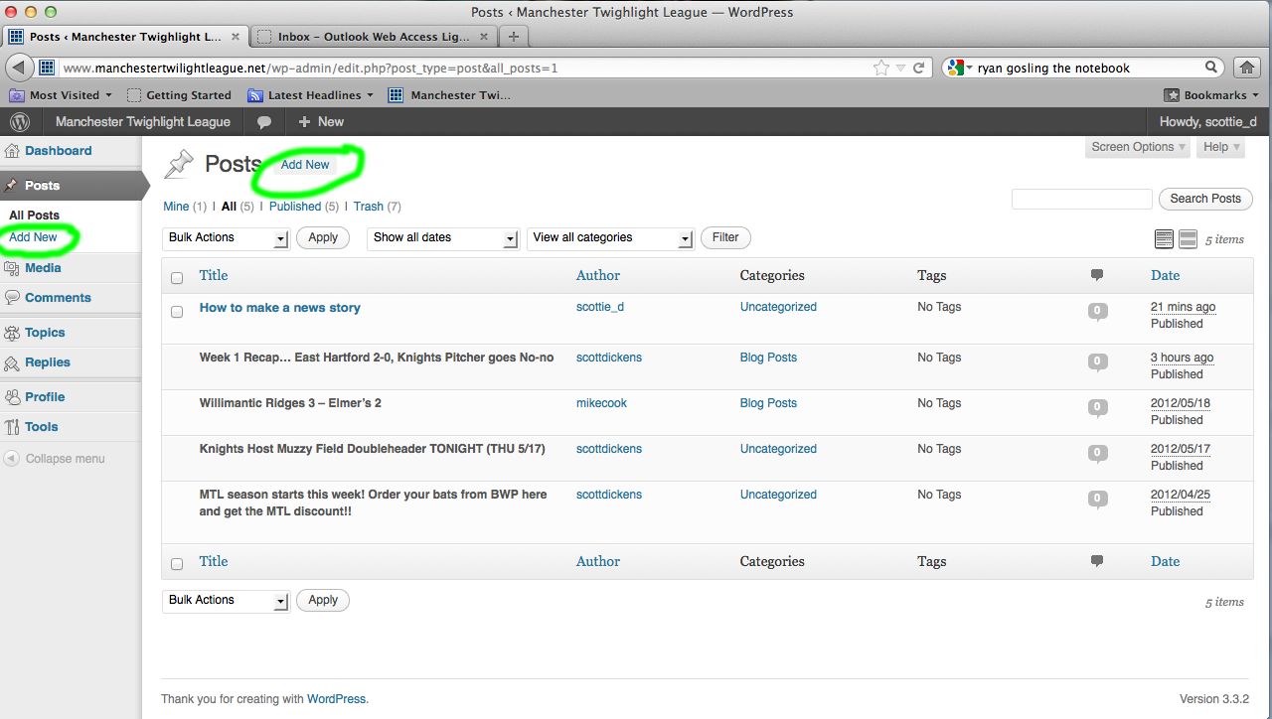

- Type a title to your post, and add body text… use the tools in the tool bar above the area for the body text to format your text as you like.
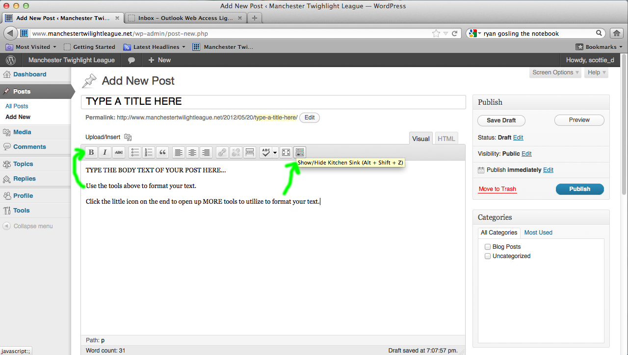

- Now you’ll see all the text formatting tools available. If you want to add photos or other media… click the add media icon.
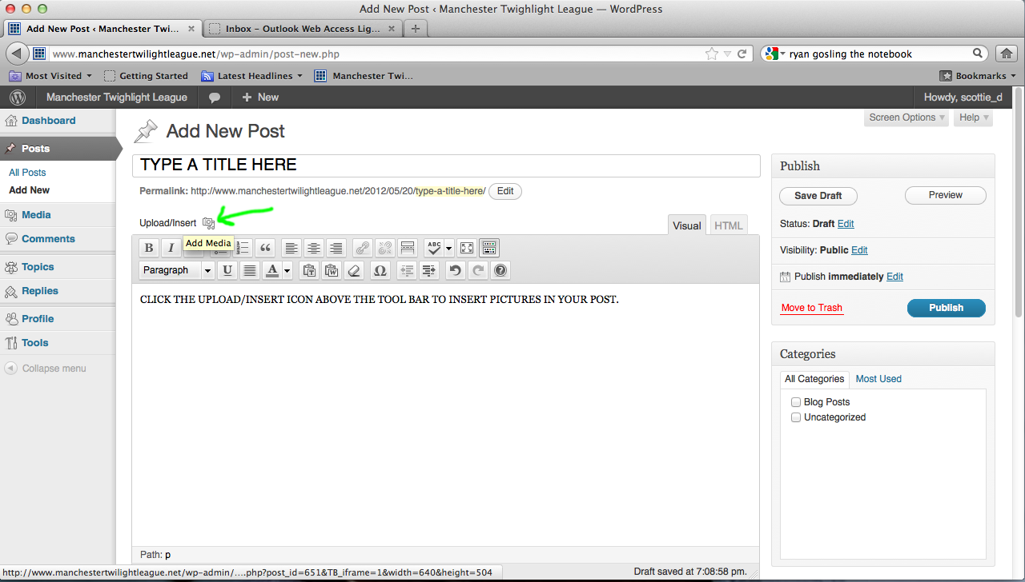

- If you have a bunch of photos… add them all at once from your computer as a gallery (GO ON TO STEP 7)… if not and you just want to add one or a couple, then skip ahead (GO TO STEP 8).

- To add them as a gallery…

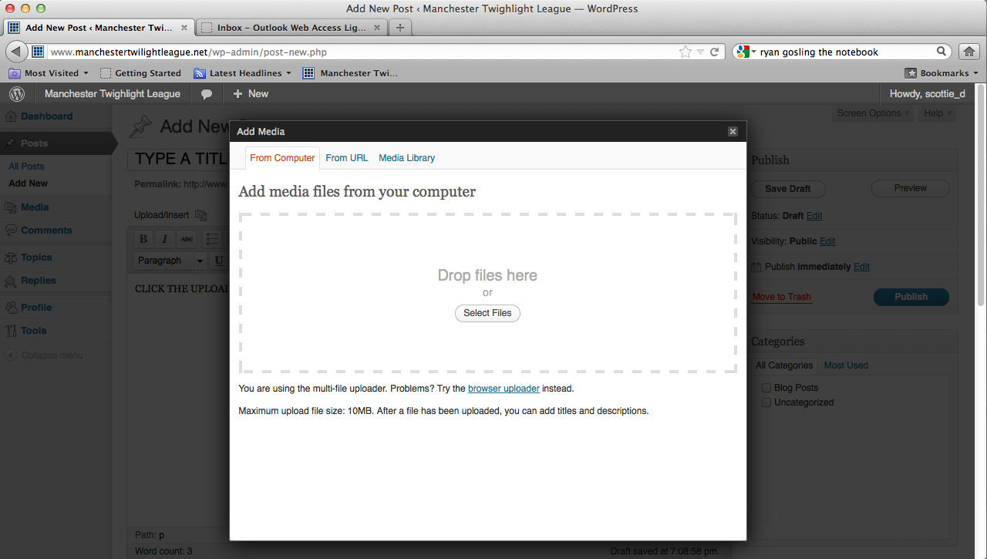
you will get this separate dialog box where you click the select file button in the middle to add them from your computer
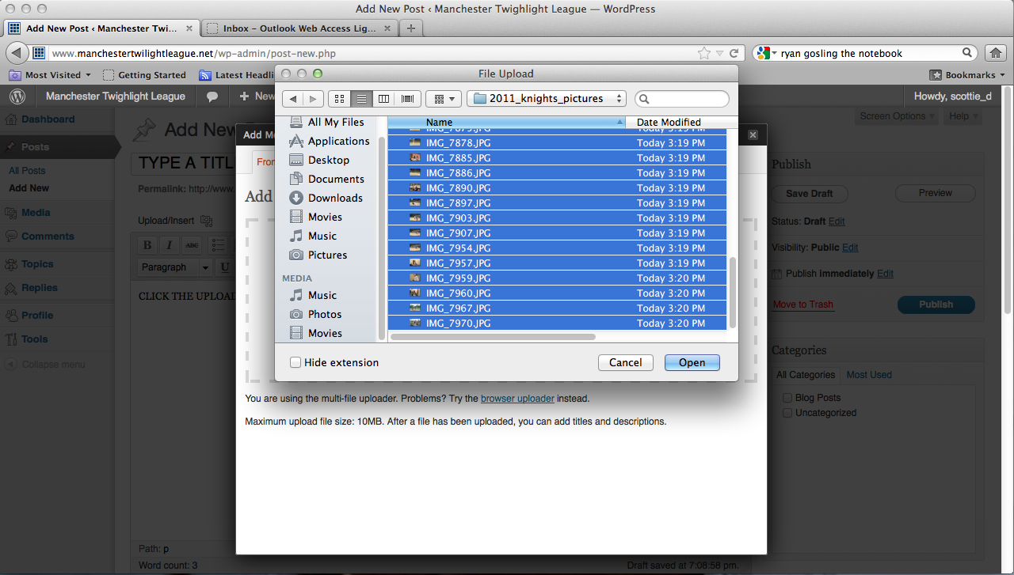
now you’ll get the dialog box that lets you pick files from your PC. If you hold shift, that is how you upload them all at once for a gallery

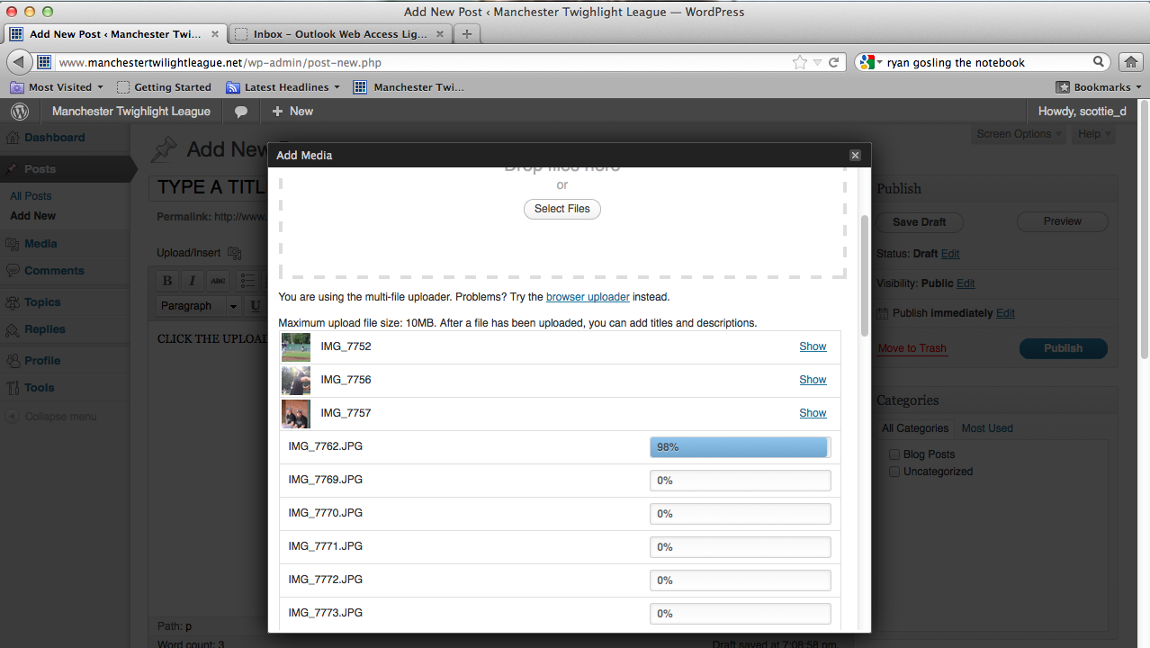
all the files will then start loading… wait until they are all done, to do anything else.

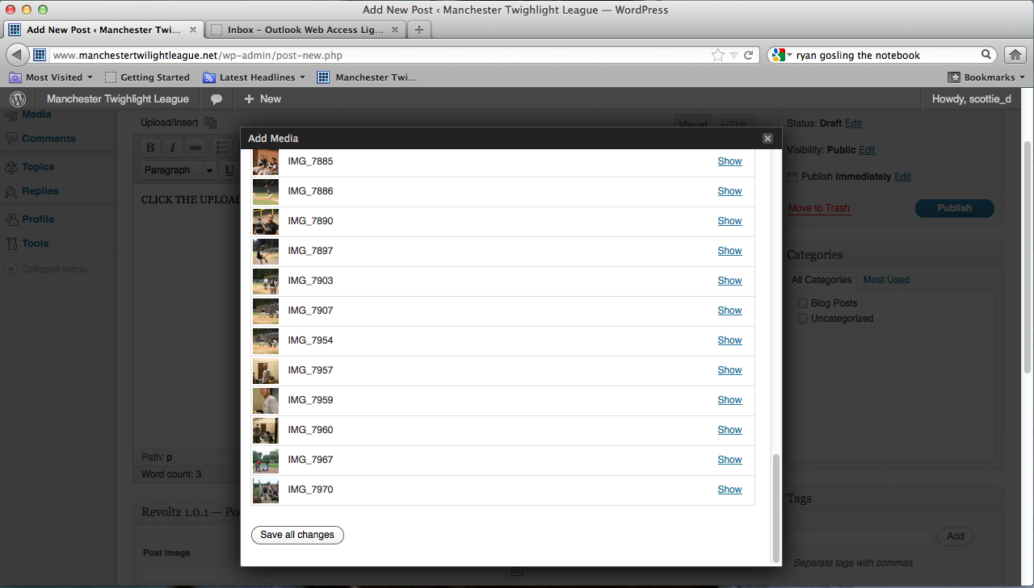
click the SAVE ALL CHANGES button at the bottom when everything is done uploading… this will bring you to the gallery screen.

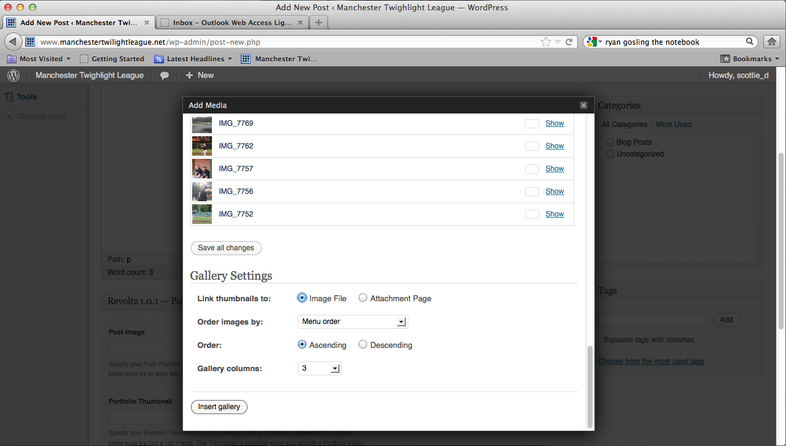
now you have the Gallery settings stuff… the way I have it checked off here is a good way to do it. THEN CLICK INSERT GALLERY

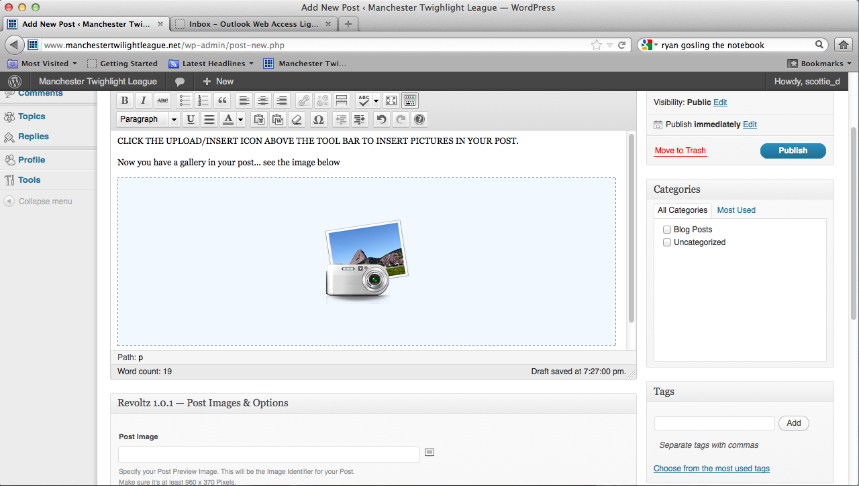
now you’ll see the camera and picture icon indicating you’ve added a gallery…

- To add them as single images in the body of your story…
After you’ve clicked the Upload/Insert buton… you’ll get the same dialog box (as if you had been doing it as a gallery)…

from here, if the images you want to add are on your computer…
you’ll click the select files button in the middle of the screen

This will bring up a dialog box to find the image(s) on your computer.
After you pick the file from your computer, watch it load and then scroll down to see the info below the image (if you don’t see all this, click SHOW next to the uploaded image).

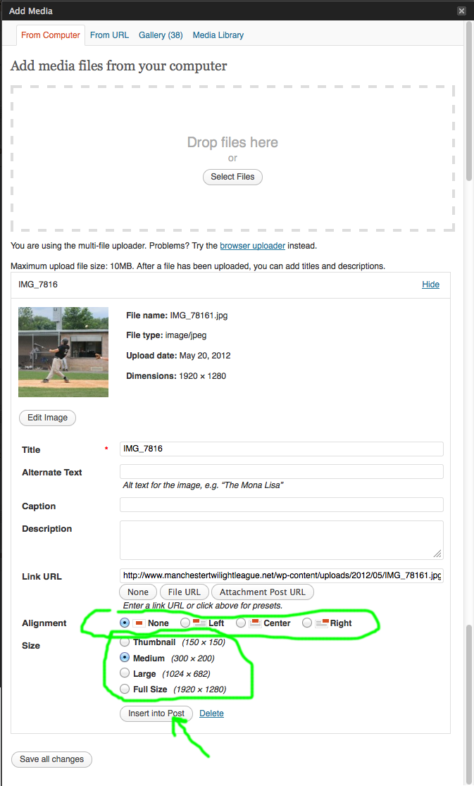
Pick if you want the picture centered by itself, left-center-or-right justified with text flowing around it… and pick an image size for how it will fit in the post. I suggest a smaller one, like Medium. Lastly, click INSERT into post.
It will look like this in the page before it’s published.
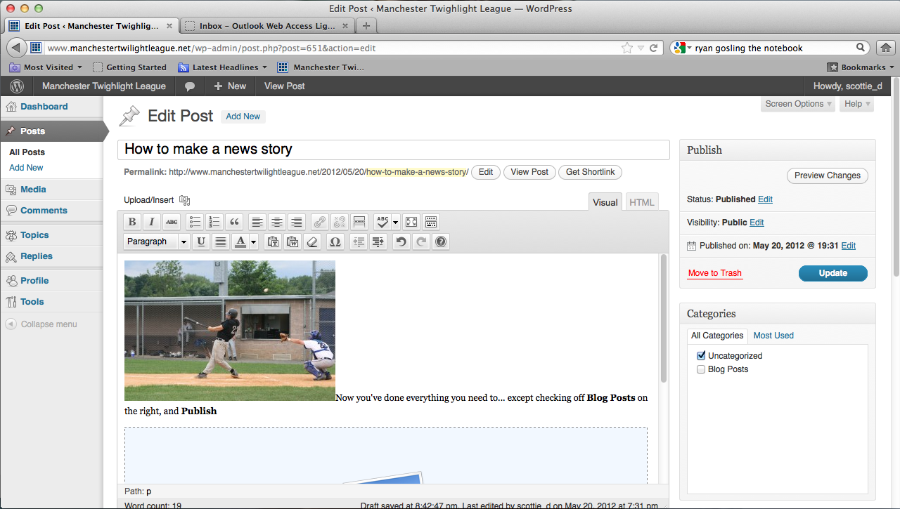

- Now you need to add a POST IMAGE… VERY IMPORTANT
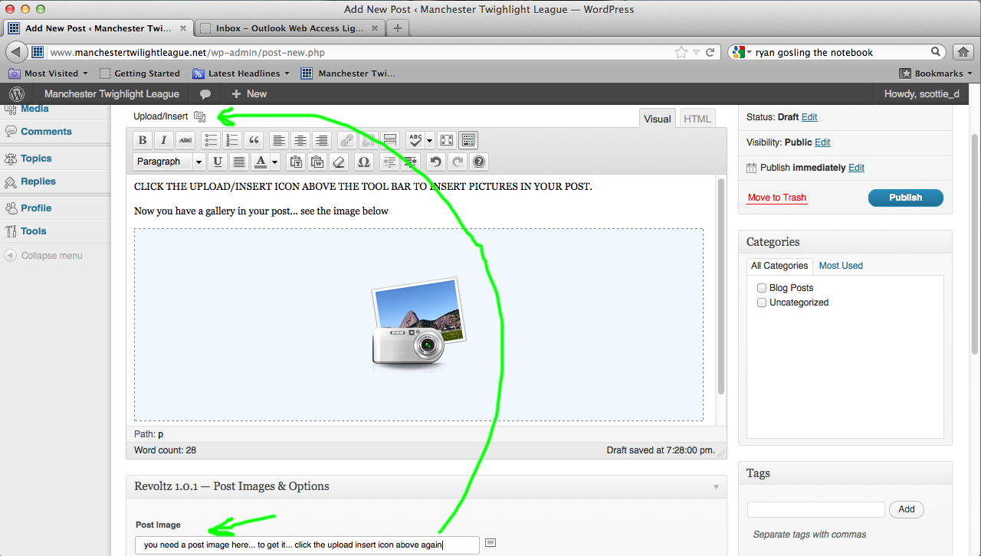
you will need to paste a web URL in this line below the big text box area. You probably want to use an images from our MEDIA LIBRARY… to do so, click UPLOAD/INSERT again.
This will give you that popup dialog box again…
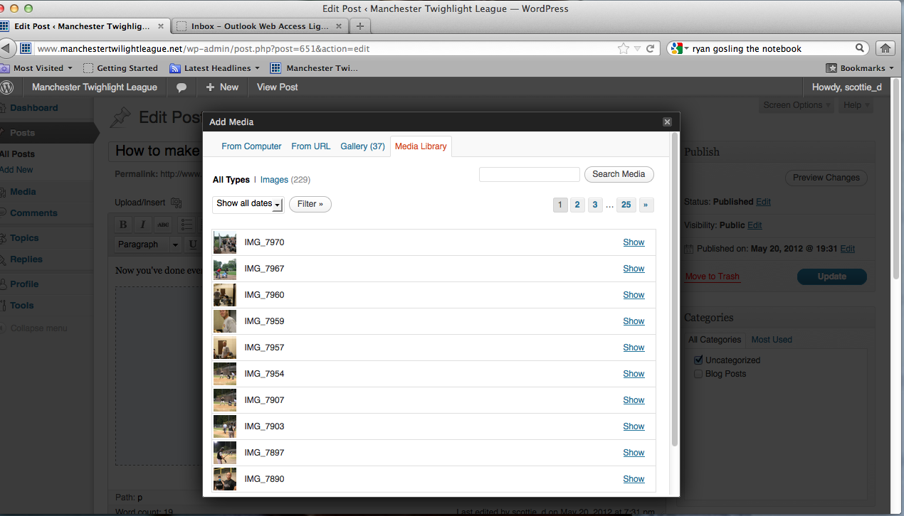
here you can type some thing in the SEARCH MEDIA area… if you want to find something for your post image… Like the Generic News Story images I made for each team. To get one of them Search for: Generic

Once you’ve located a picture you want to use for the post image…
CLICK SHOW to the right of the image you want.
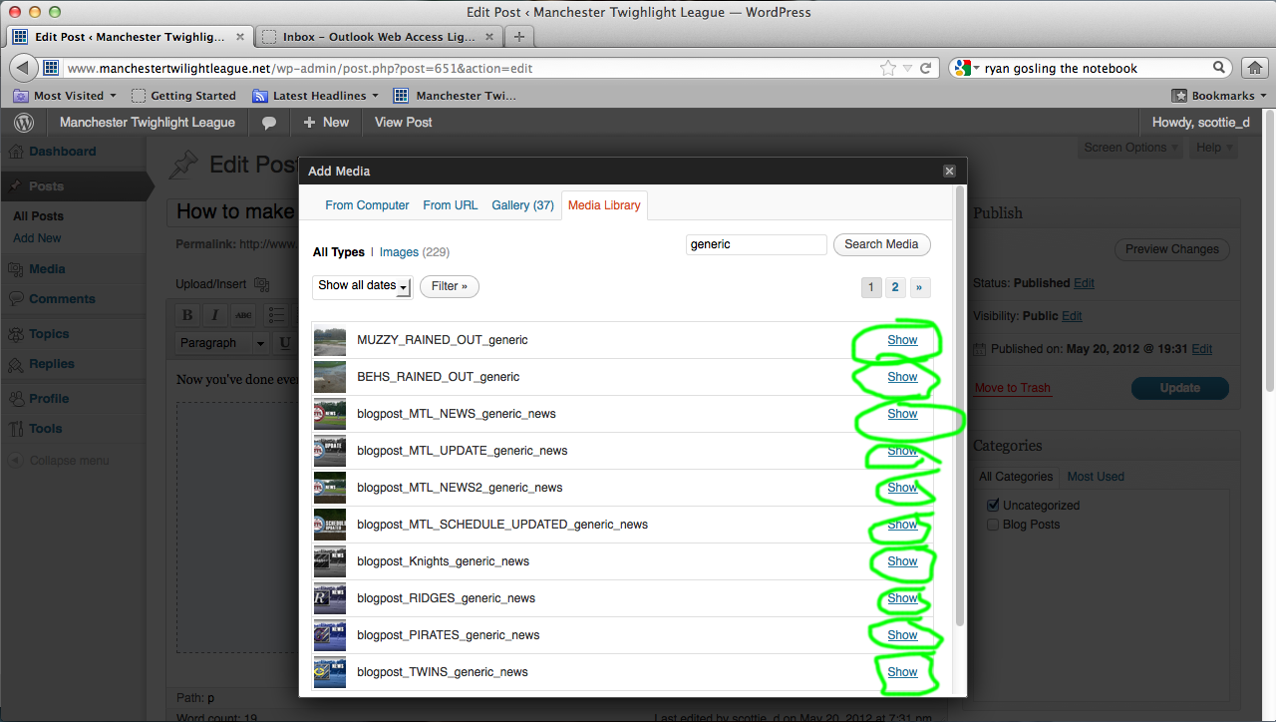

Once you clicked show… it will open a bunch of info about that media.
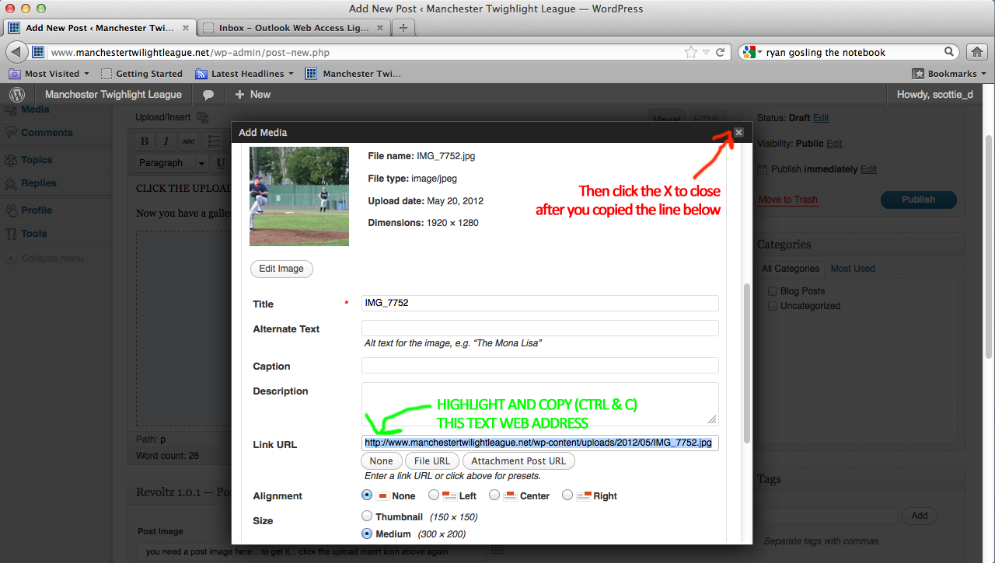
HIGHLIHT AND COPY (ctrl-c) ALL THE TEXT IN THE LINK URL… and close this window with the X in the upper right corner.

The last part of Adding the POST IMAGE is then pasting that web address in the post image URL spot below the main text area…
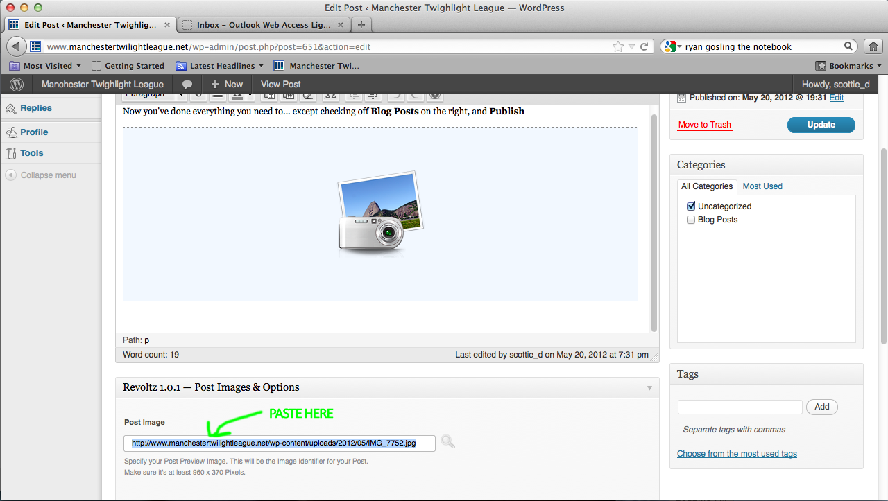

NOW YOUR NEWSTORY HAS A PICTURE TO GO WITH IT…

- Last couple steps… check off BLOG POSTS on the right side of the page, and then click PUBLISH
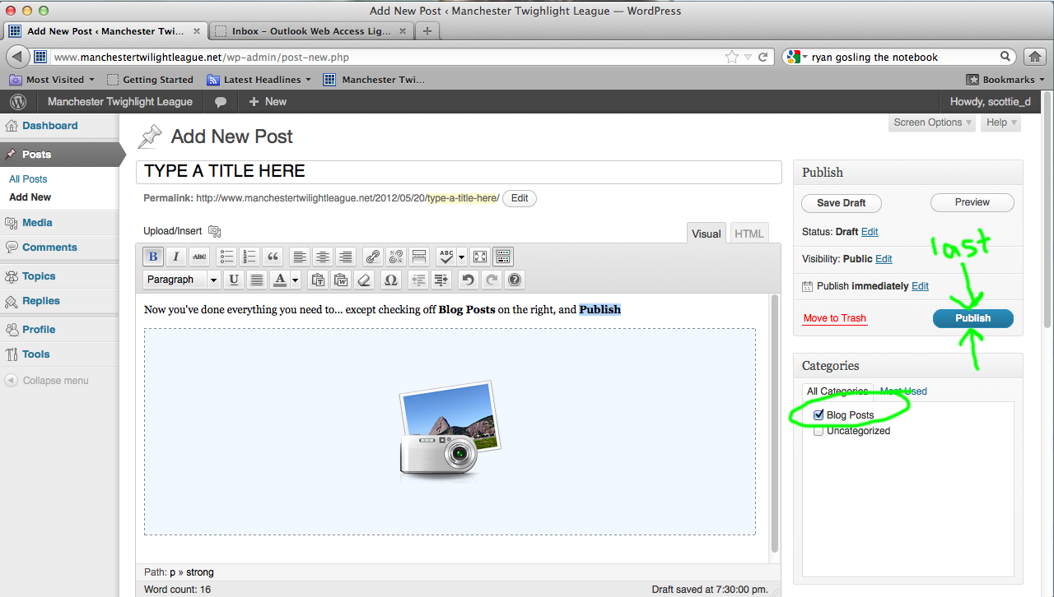

After you clicked publish… a yellow bar with the text VIEW POST will appear… click it to view your post on the site to make sure everything looks great.
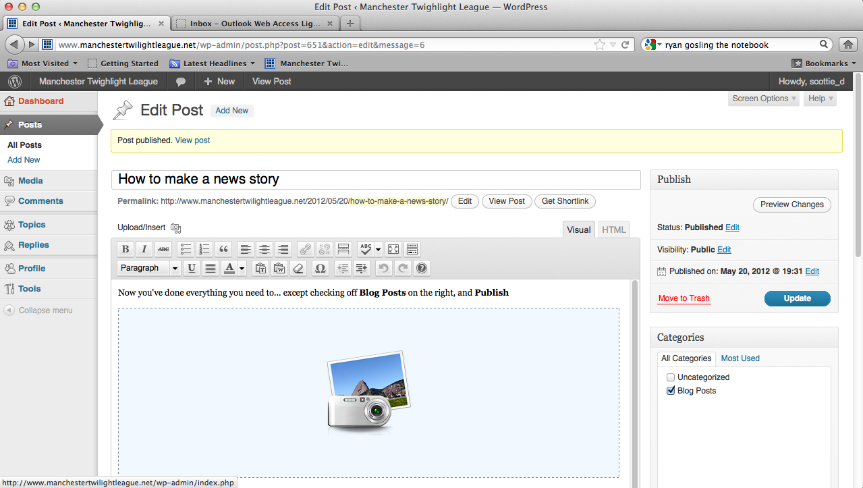

Here is how this Fake example story I just built looks.
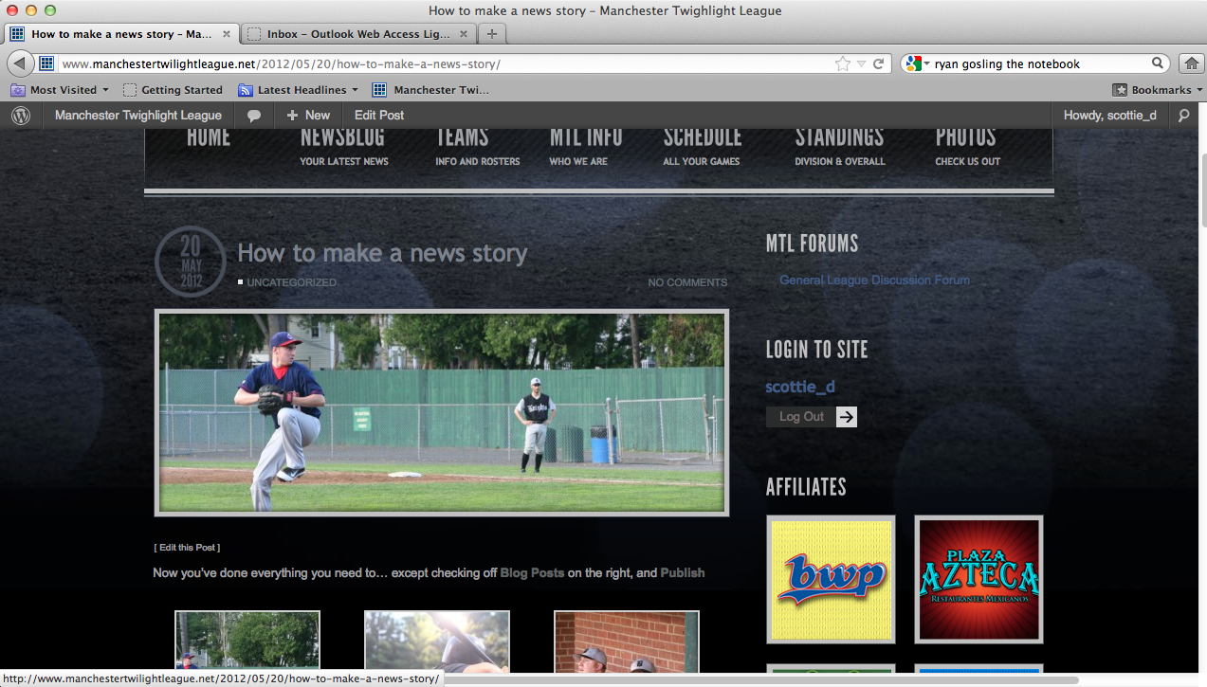

You can go back at any time and UPDATE the text or content of your post… or delete it if you’d like. Feel free to delete anything YOU did… but I think its best to leave it… and next time you want to add a news story, make a new one.

As long as you checked BLOG POSTS… your story will be one of the ones rotating through the main area on the Front Page of the site.

